**Lab 8 Deliverables**

Akaash Chikarmane and Milan Feliciello

Section: 16085

Spring 2016

**Schematic**

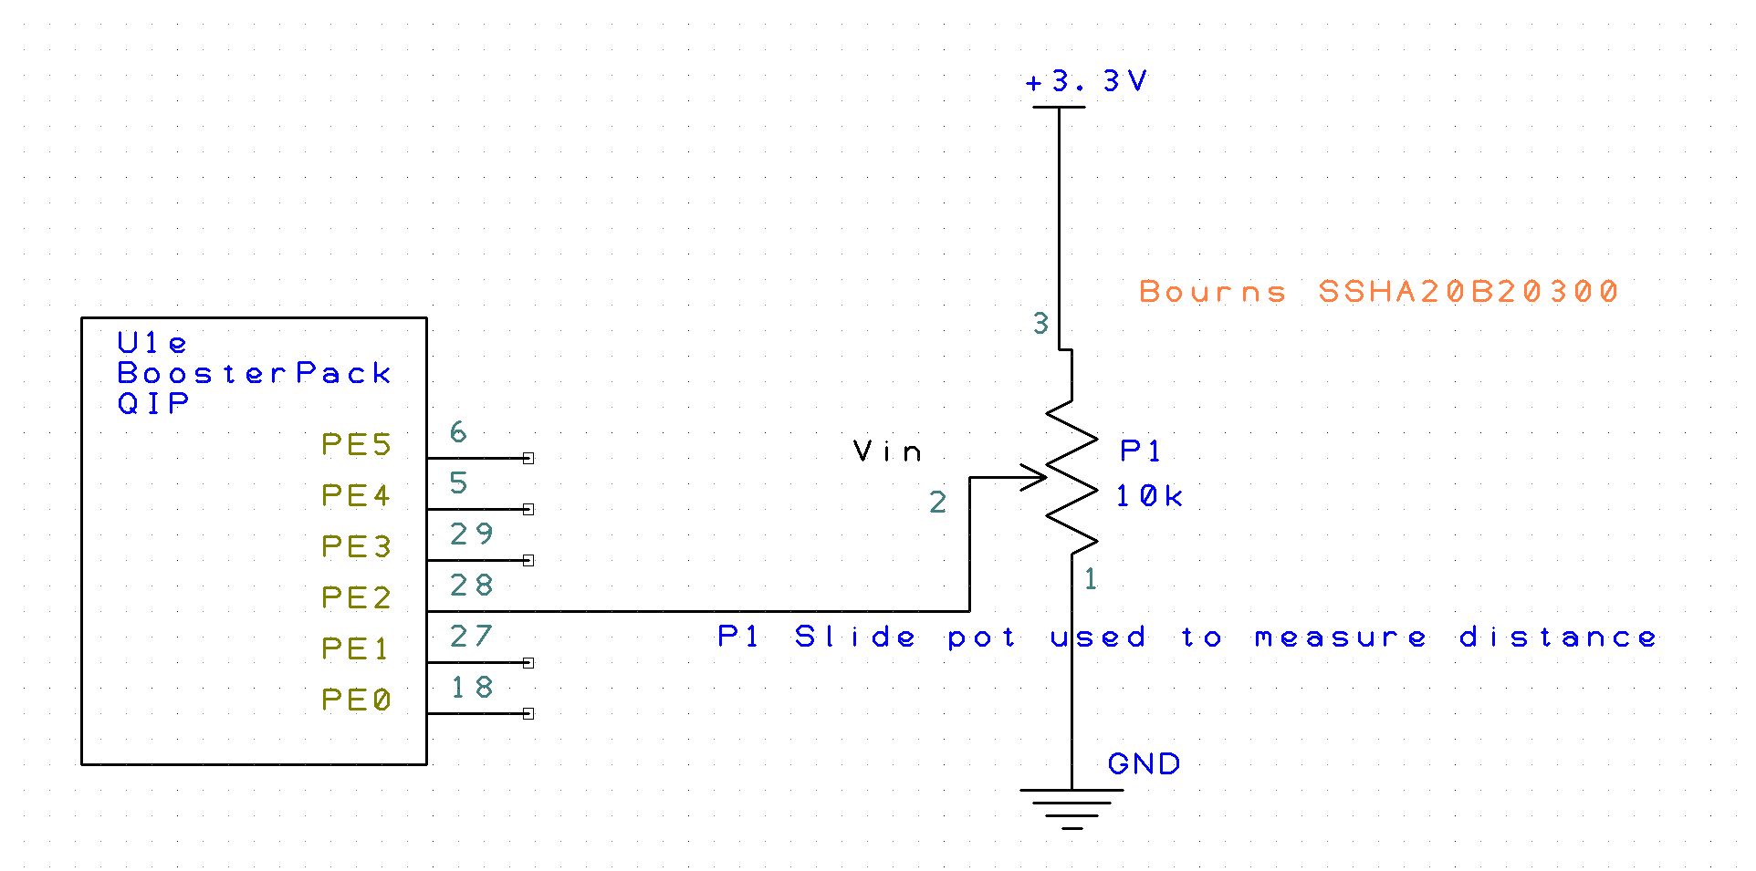

**Time Measurements (like Figure 8.6)**

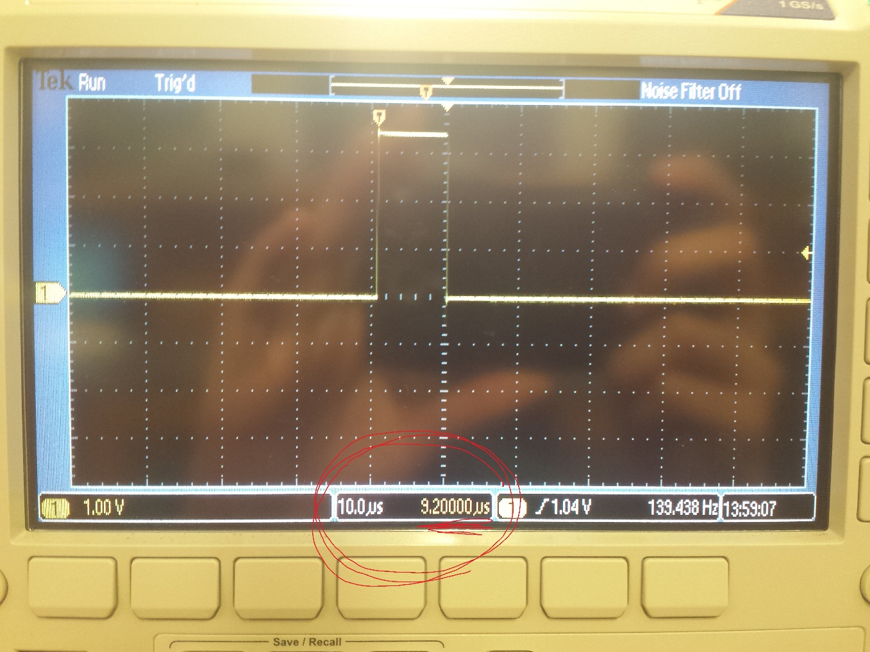

ADC execution time

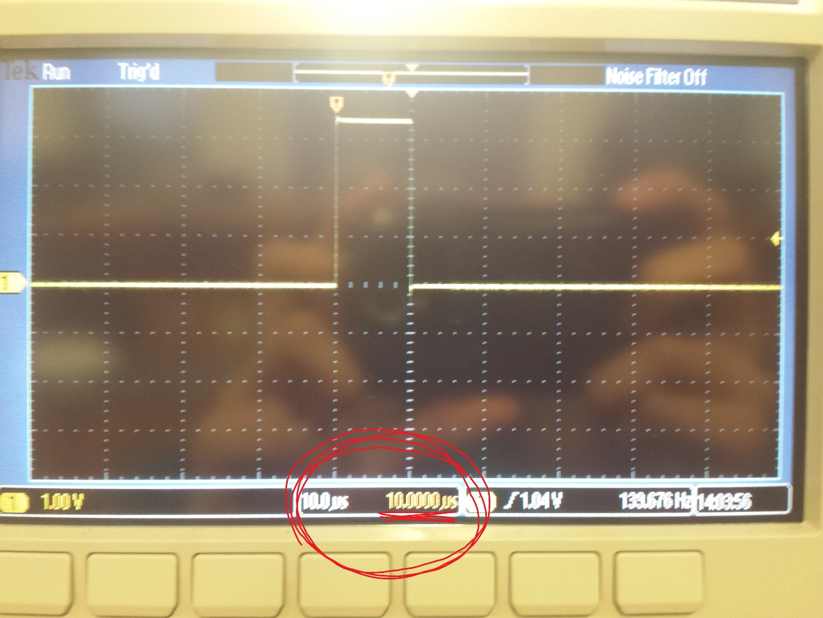

LCD execution time

**Calibration Data**

|  |  |  |
| --- | --- | --- |
| Position (cm) | Analog Input (V) | ADC Sample |
| 0 | 0.01 | 13 |
| 0.25 | 0.12 | 150 |
| 0.5 | 0.62 | 700 |
| 0.75 | 1.07 | 1250 |
| 1 | 1.6 | 1900 |
| 1.25 | 2.08 | 2500 |
| 1.5 | 2.53 | 3100 |
| 1.75 | 3.03 | 3750 |
| 2 | 3.28 | 4095 |

**Final Distance Meter**

void SysTick_Handler(void){

GPIO_PORTF_DATA_R ^= 0x0C;

ADCMail = ADC_In();

ADCStatus = 0x00000001;

GPIO_PORTF_DATA_R ^= 0x0C;

return;

}

uint32_t delay;

// ADC initialization function

// Input: none

// Output: none

void ADC_Init(void){

SYSCTL_RCGC2_R |= 0x10; //1) activate PORTE clock

while(SYSCTL_RCGC2_R == 0){ //null

}

GPIO_PORTE_DIR_R &= ~0x04; //2) make PE2 input

GPIO_PORTE_AFSEL_R |= 0x04; //3) enable alternate function for PE2

GPIO_PORTE_DEN_R &= ~0x04; //4) disable digital I/O for PE2

GPIO_PORTE_AMSEL_R |= 0x04; //5) enable analong function on PE2

SYSCTL_RCGCADC_R |= 0x01; //6) activate ADC0

delay = SYSCTL_RCGCADC_R; //null

delay = SYSCTL_RCGCADC_R; //null

delay = SYSCTL_RCGCADC_R; //null

delay = SYSCTL_RCGCADC_R; //null

ADC0_PC_R = 0x01; //7) configure for 125k

ADC0_SSPRI_R &= ~0x0123; //8) Seq3 is highest priority

ADC0_ACTSS_R &= ~0x0008; //9) disable sample sequencer 3

ADC0_EMUX_R &= ~0xF000; //10) seq3 is software trigger

ADC0_SSMUX3_R = (ADC0_SSMUX3_R & 0xFFFFFFF0) + 1; //11) Ain1 (PE2)

ADC0_SSCTL3_R = 0x0006; //12) no TS0D0, yes IE0 END0

ADC0_IM_R &= ~0x0008; //13) disable SS3 interrupts

ADC0_ACTSS_R |= 0x0008; //14) enable sample sequencer 3

}

//------------ADC_In------------

// Busy-wait Analog to digital conversion

// Input: none

// Output: 12-bit result of ADC conversion

uint32_t ADC_In(void){

uint32_t result;

ADC0_PSSI_R = 0x0008; //1) initiate SS3

while((ADC0_RIS_R & 0x08) == 0){ //2) wait for conversion to finish

}

result = ADC0_SSFIFO3_R & 0xFFF; //3) read 12-bit result

ADC0_ISC_R = 0x0008; //4) acknowledge completion

return(result);

}

uint32_t Convert(uint32_t input){

uint32_t converted;

converted = input*100;

converted = (converted + 29203);

converted = (converted/223);

return(converted);

}

int main(void){

TExaS_Init(); // Bus clock is 80 MHz

ST7735_InitR(INITR_REDTAB);

PortF_Init();

ADC_Init(); // turn on ADC, set channel to 1

SysTick_Init();

while(1){

if(ADCStatus == 1){

ADCStatus = 0;

measurement = Convert(ADCMail);

ST7735_SetCursor(0,0);

LCD_OutFix(measurement);

ST7735_OutChar(0x20);

ST7735_OutChar(0x63);

ST7735_OutChar(0x6D);

}

}

}

**Sampling Rate of 40 Hz (Figure 8.8)**

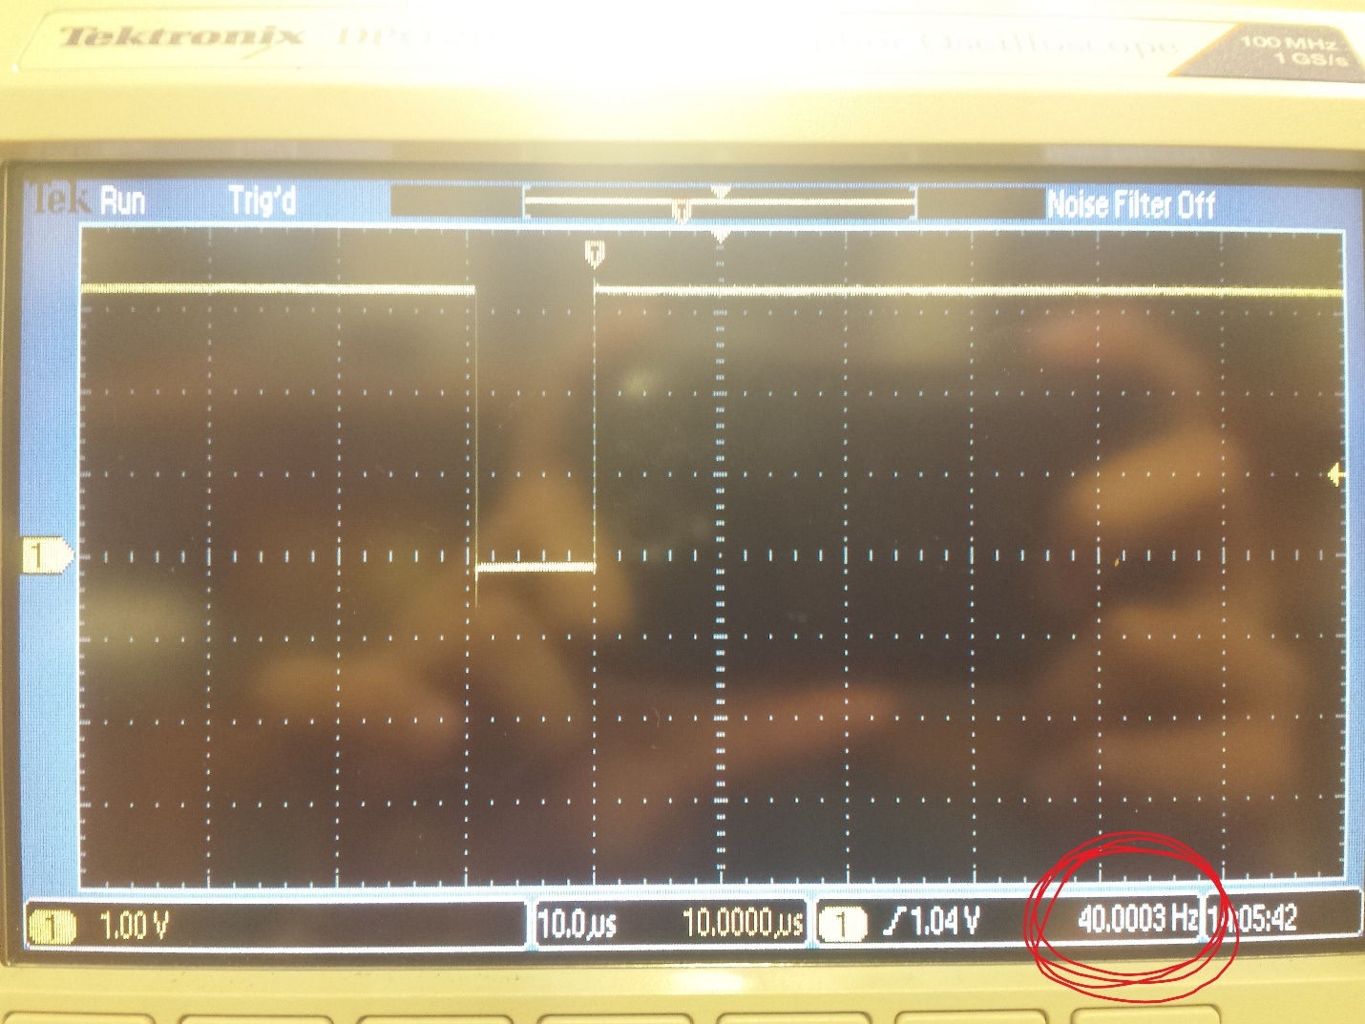

**Accuracy Data and Accuracy Calculation**

|  |  |  |  |
| --- | --- | --- | --- |
| True Values | Measured values | | Errors |
| 0 | 0.136 | | -0.136 |
| 0.5 | 0.444 | | 0.056 |
| 1 | 0.982 | | 0.018 |
| 1.5 | 1.521 | | -0.021 |
| 2 | 1.967 | | 0.033 |
|  |  | |  |
| Average error | | |  |
| 0.053 |  |